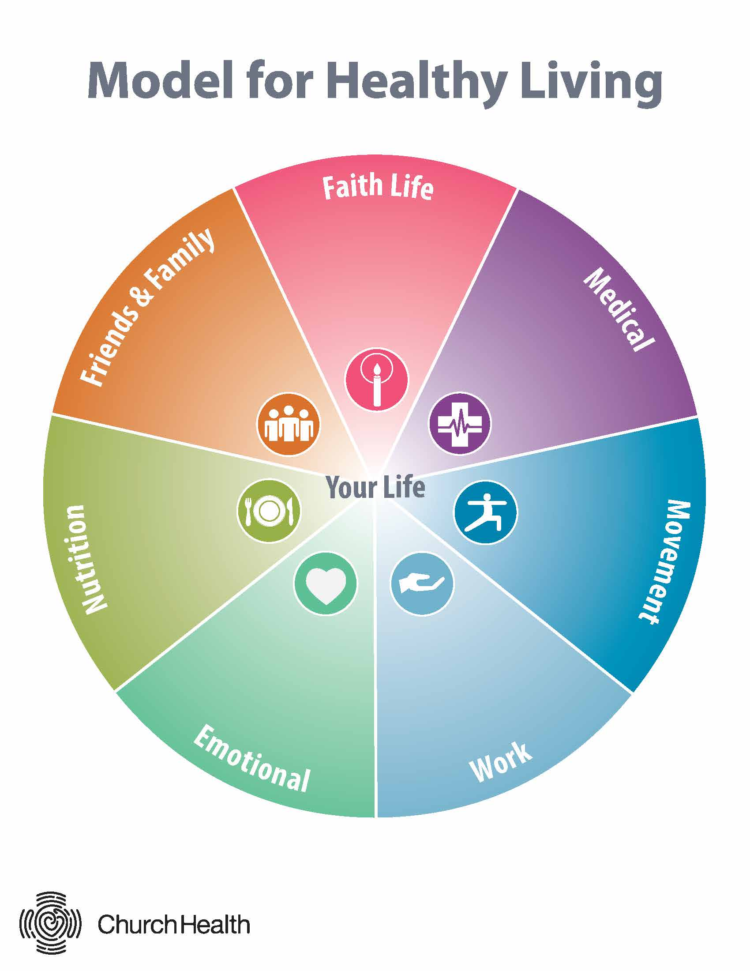
Medical
https://chreader.org/power-prevention/
https://blog.ohiohealth.com/the-three-pillars-of-brain-health-mind-body-spirit/
https://blog.ohiohealth.com/mens-health-screenings/
End of Life pdfs and video

Movement
https://chreader.org/mindfulness-of-our-bodies/
https://blog.ohiohealth.com/the-benefits-of-changing-up-your-exercise-routine/
https://chreader.org/gym-phobia/

Work
https://chreader.org/the-gift-of-work/
https://chreader.org/restoring-the-healer/
https://www.westohioumc.org/conference/news/what-did-wesley-practice-and-preach-about-money

Emotional
https://chreader.org/congregational-mental-health/
https://www.latimes.com/opinion/op-ed/la-xpm-2013-apr-07-la-oe-0407-silk-ring-theory-20130407-story.html
https://www.mentalhealthfirstaid.org/

Nutrition
https://blog.ohiohealth.com/series/diets-deconstructed/
https://blog.ohiohealth.com/healthy-mason-jar-recipes/
https://blog.ohiohealth.com/wp-content/uploads/2019/10/Mom-on-a-Mission-Cheat-Sheet-Eating-Healthy-Away-from-Home.pdf

Friends & Family
https://blog.ohiohealth.com/e-cigarettes-separate-fact-fiction/
https://blog.ohiohealth.com/how-much-screen-time-is-okayfor-teenagers/

Faith Life
https://www.westohioumc.org/conference/resources-1

Relationship to OhioHealth
https://www.westohioumc.org/conference/news/ohiohealth-west-ohio-conferences-healthcare-system-0

OhioHealth & West Ohio Conference - “Health Minute” Production Calendar
WEEK # | WEEKLY THEME | FILMING DATES | EMAIL PUSH/WEBSITE DATES | LINKS/ RESOURCES | NOTES AND COMMENTS
MONTH A - WHAT IS HEALTH?
WEEK ONE | Romans 12 | TBD | Need from WOC partners | External  Article: http://chreader.org/what-is-healthy-eating/  Video: https://www.youtube.com/watch?time_continue=4&v=whPuRLil4c0 https://www.youtube.com/watch?time_continue=4&v=whPuRLil4c0  Book: Dust and Breath: Faith, Health, and Why the Church Should Care About Both  OhioHealth  https://blog.ohiohealth.com/four-tips-eating-organic-smart-way/  https://blog.ohiohealth.com/the-science-of-creating-healthy-habits-3-steps-to-make-or-break-a-habit/  https://blog.ohiohealth.com/container-gardening-grow-herbs-and-veggies-in-small-spaces/  https://blog.ohiohealth.com/how-to-start-exercising/  https://blog.ohiohealth.com/run-jog-or-walk-spring-races-to-get-you-moving/  https://blog.ohiohealth.com/drink-more-water-winter/  https://blog.ohiohealth.com/ways-achieve-health-goals/
WEEK TWO | Strength | TBD | Need from WOC partners | External  http://chreader.org/christian-body-image/  http://chreader.org/why-walk/  OhioHealth  https://blog.ohiohealth.com/how-to-relieve-stress/  https://blog.ohiohealth.com/6-heart-healthy-habits-for-women-that-you-can-start-today/  https://blog.ohiohealth.com/adult-coloring/  https://blog.ohiohealth.com/showing-gratitude-important-heres-get-started/  https://blog.ohiohealth.com/apps-to-help-you-find-your-calm/  https://blog.ohiohealth.com/what-is-art-therapy/  https://blog.ohiohealth.com/sleep-app/
WEEK THREE | Temple of HS | TBD | Need from WOC partners | External  https://www.ted.com/talks/meaghan_ramsey_why_thinking_you_re_ugly_is_bad_for_you#t-710322  https://onbeing.org/programs/matthew-sanford-the-bodys-grace/
WEEK FOUR | Accountability | TBD | Need from WOC partners | External  http://chreader.org/around-church/
MONTH B - MODEL FOR HEALTHY LIVING
WEEK ONE | CHreader model | TBD | Need from WOC partners | External  http://chreader.org/model-healthy-living2/  https://www.livingcompass.org/assessment-introduction/  https://www.wespath.org/center-for-health/resources/wellness-toolkits/
WEEK TWO | Movement | TBD | Need from WOC partners | External  https://www.wespath.org/assets/1/7/5080.pdf
WEEK THREE | Friends & Family | TBD | Need from WOC partners | External  https://www.wespath.org/assets/1/7/5007.pdf
WEEK FOUR | Nutrition | TBD | Need from WOC partners | External  https://www.youtube.com/watch?v=9WC8A1Lrq8M  https://www.wespath.org/assets/1/7/4893.pdf
This page has other health resources that can be added month to month.

